Binary spits 🡪 false

Unpruned 🡪 false

Confidence factor 🡪 0.25

Minimal number of objects 🡪 2

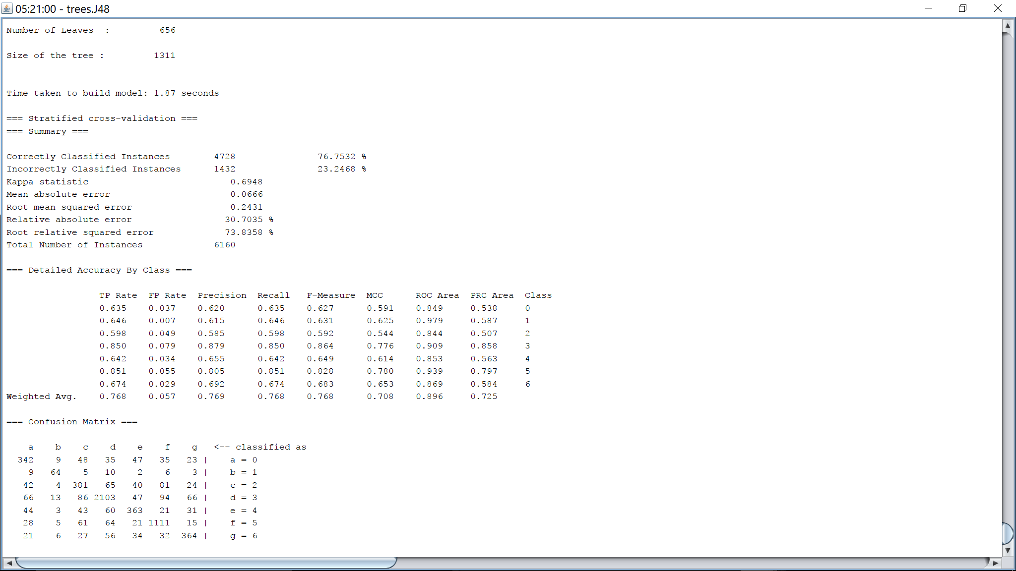

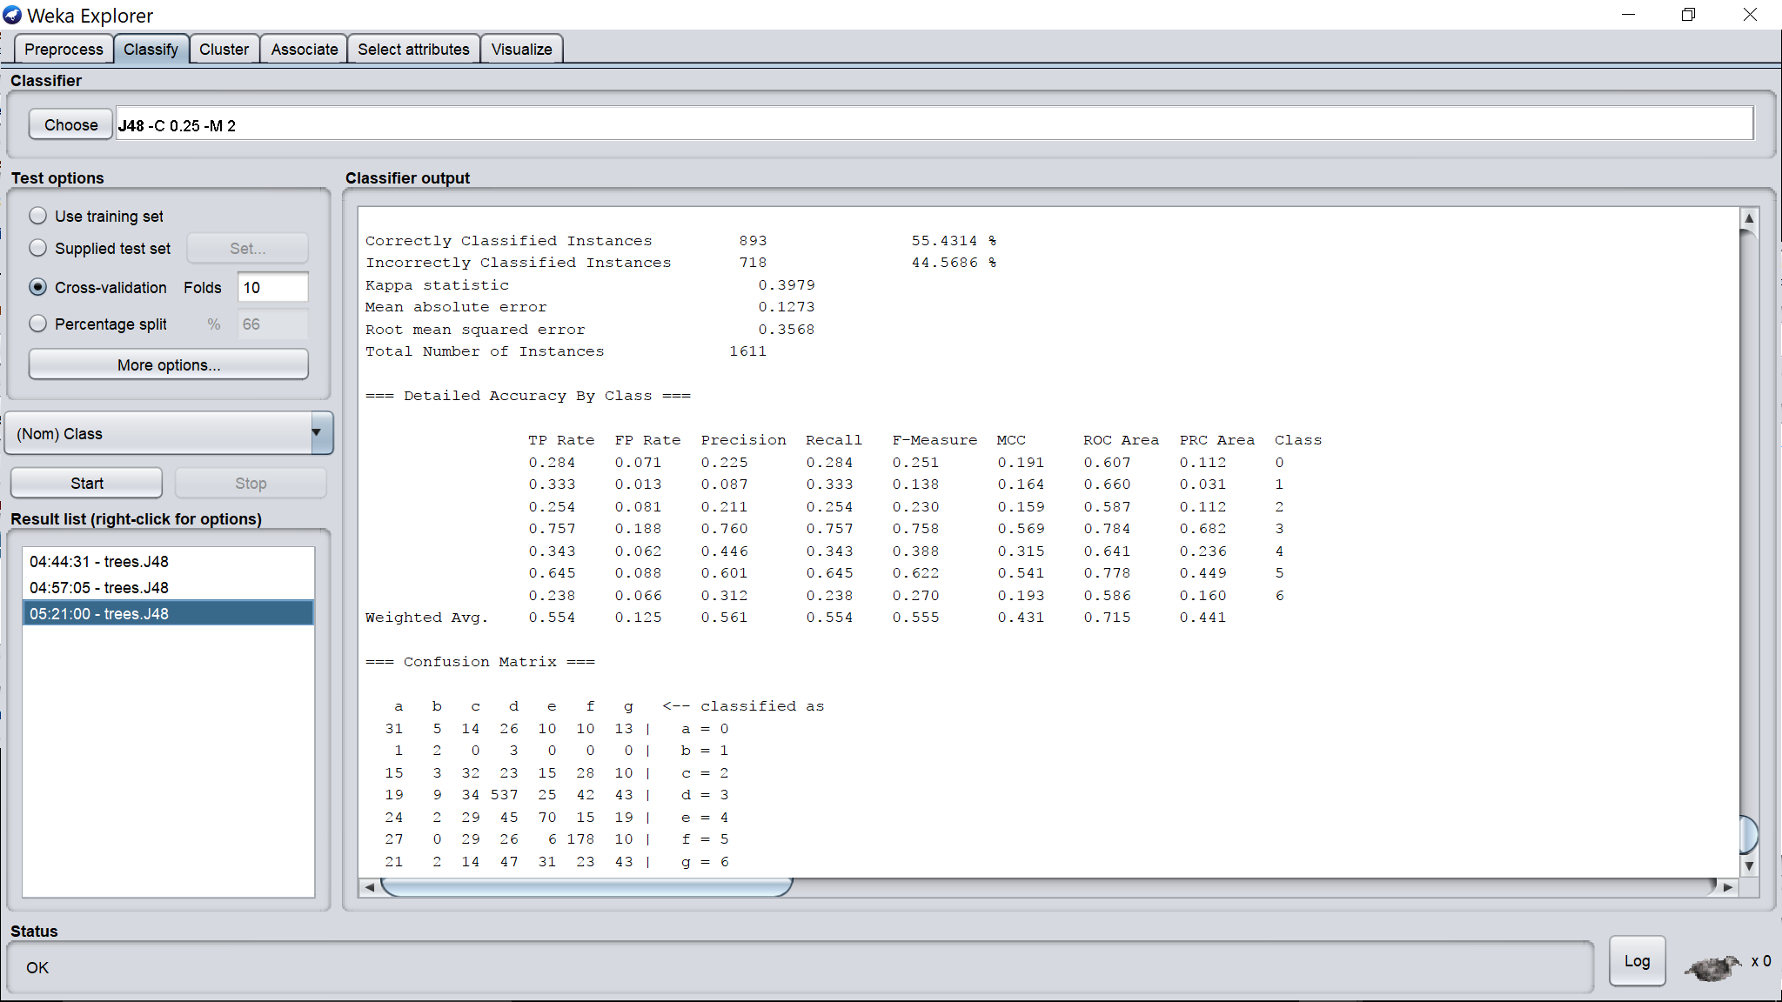

Binary spits 🡪 false

Unpruned 🡪 false

Confidence factor 🡪 0.25

Minimal number of objects 🡪 1

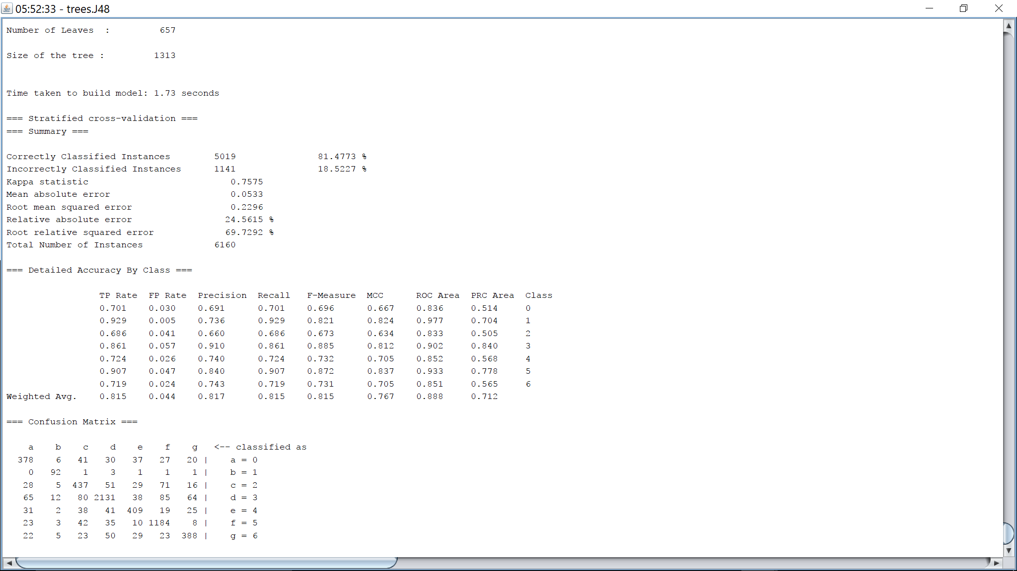

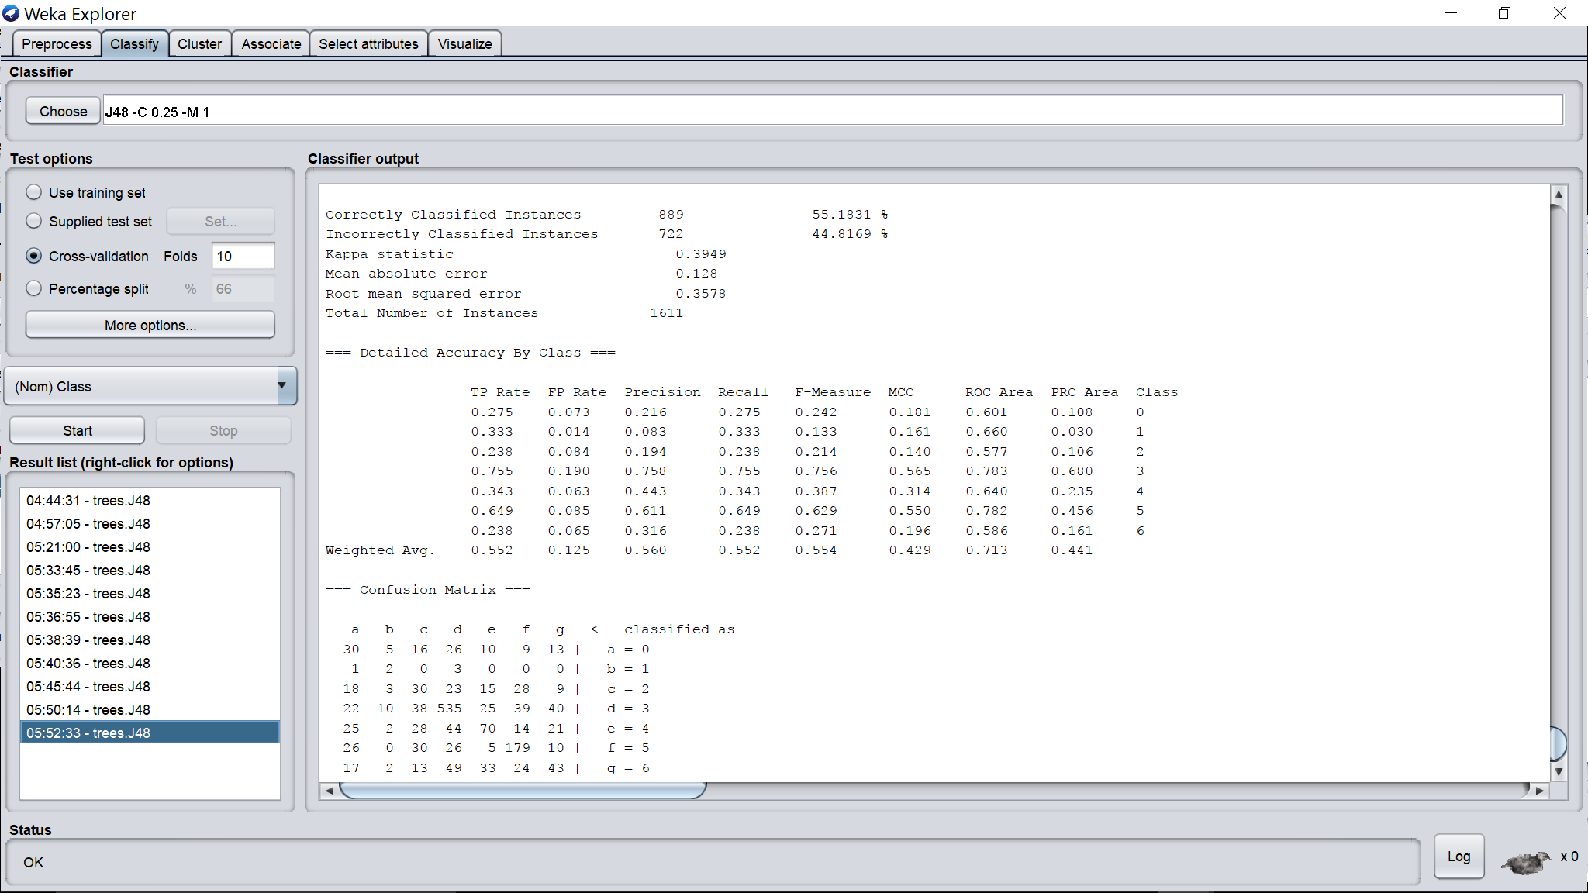

Binary spits 🡪 false

Unpruned 🡪 false

Confidence factor 🡪 0.25

Minimal number of objects 🡪 3

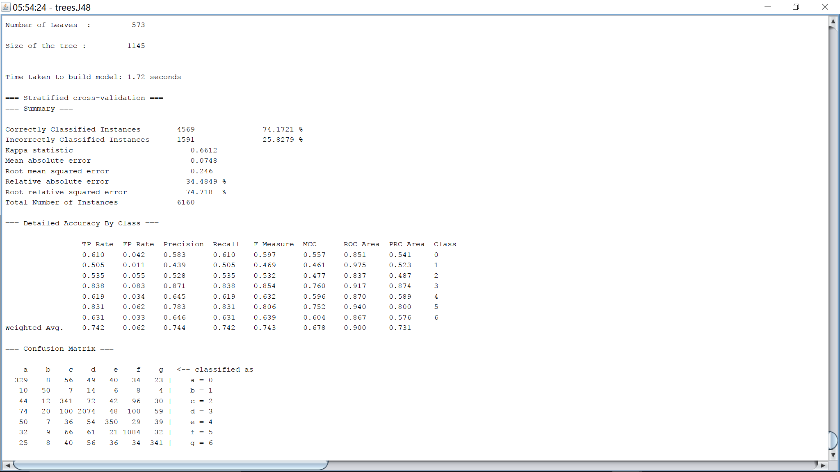

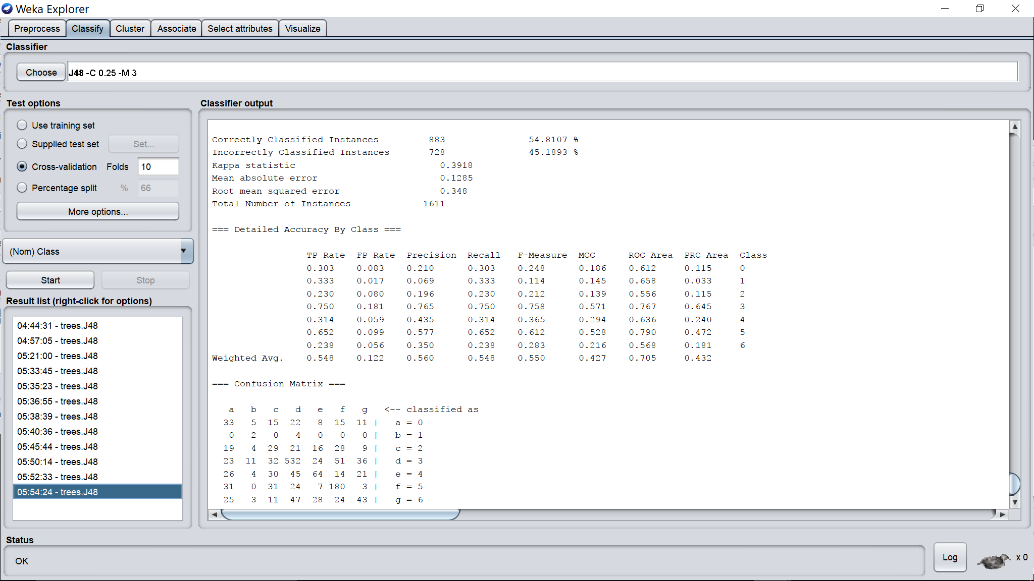

Binary spits 🡪 false

Unpruned 🡪 false

Confidence factor 🡪 0.25

Minimal number of objects 🡪 5

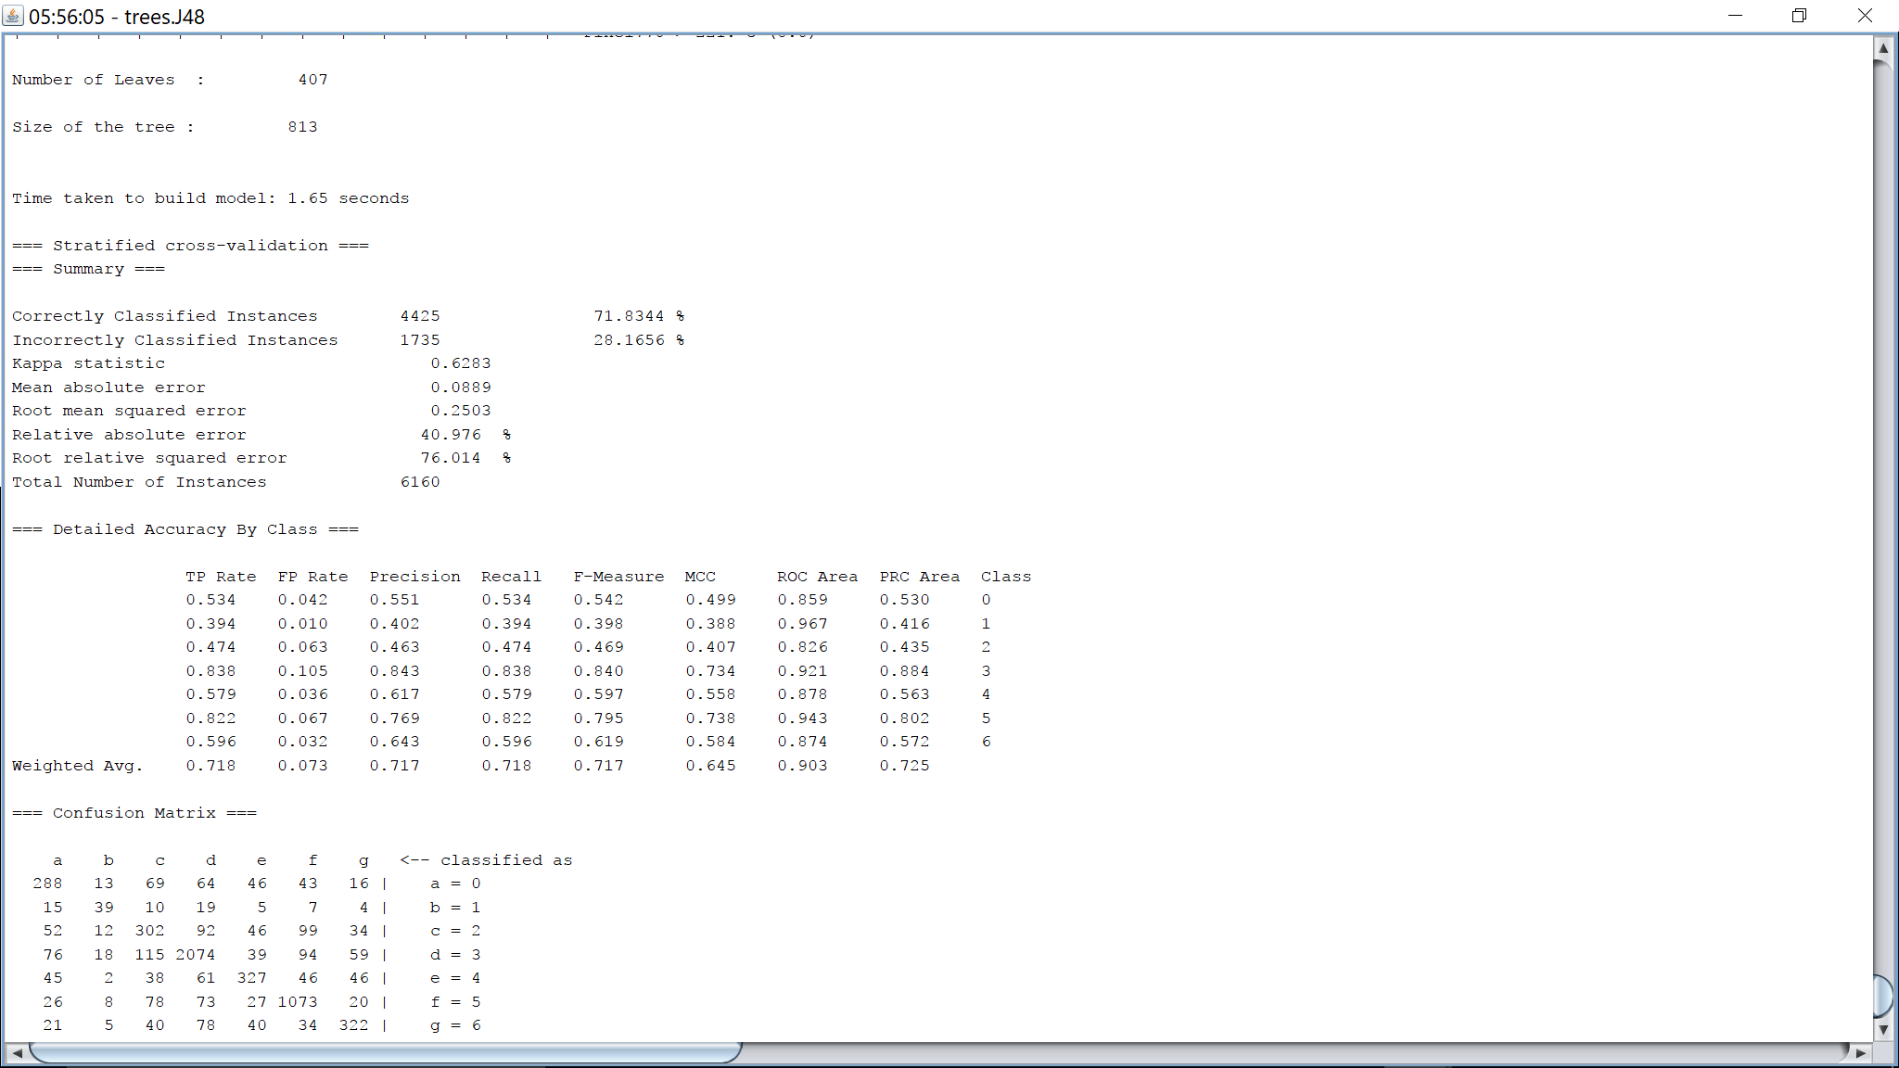

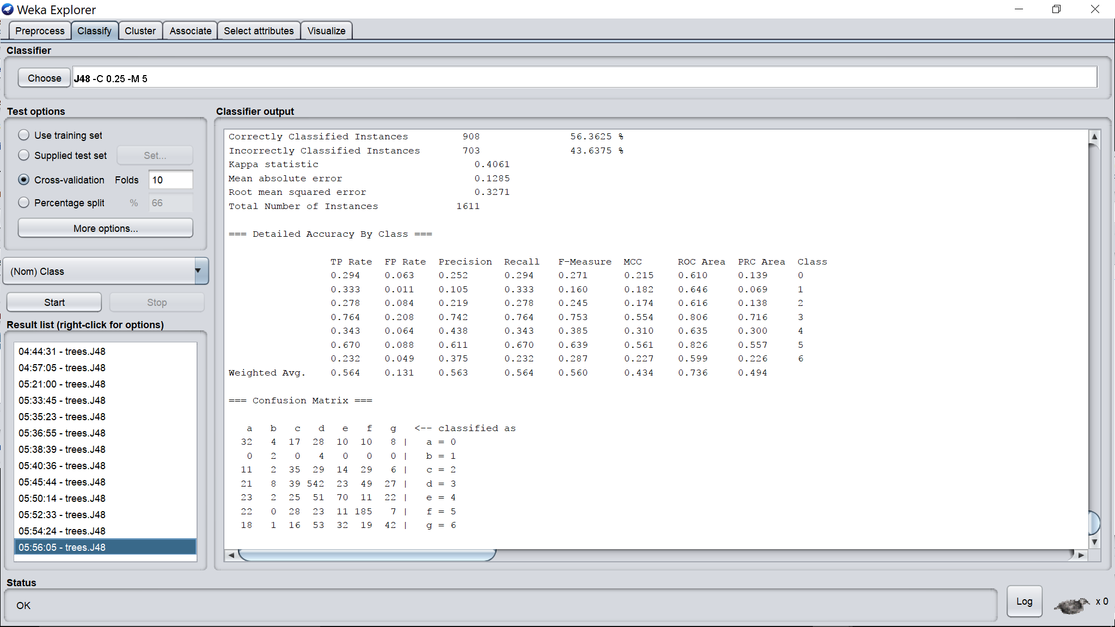

Binary spits 🡪 false

Unpruned 🡪 false

Confidence factor 🡪 0.25

Minimal number of objects 🡪 10

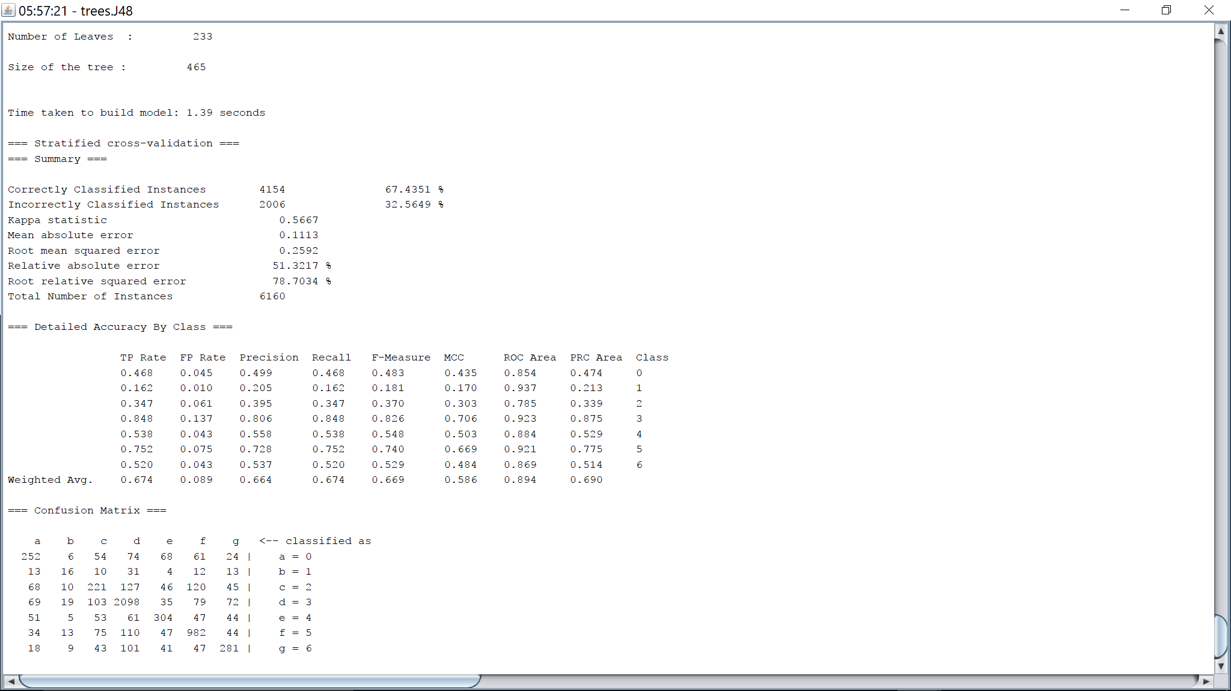

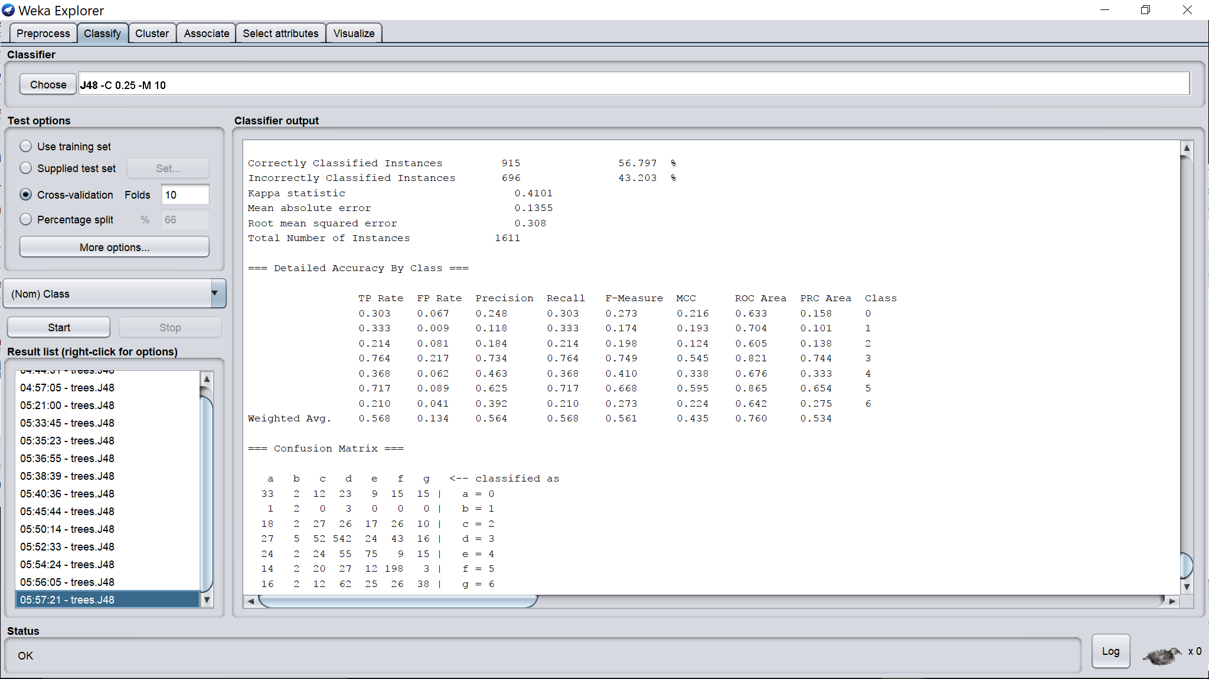

Binary spits 🡪 false

Unpruned 🡪 false

Confidence factor 🡪 0.25

Minimal number of objects 🡪 20

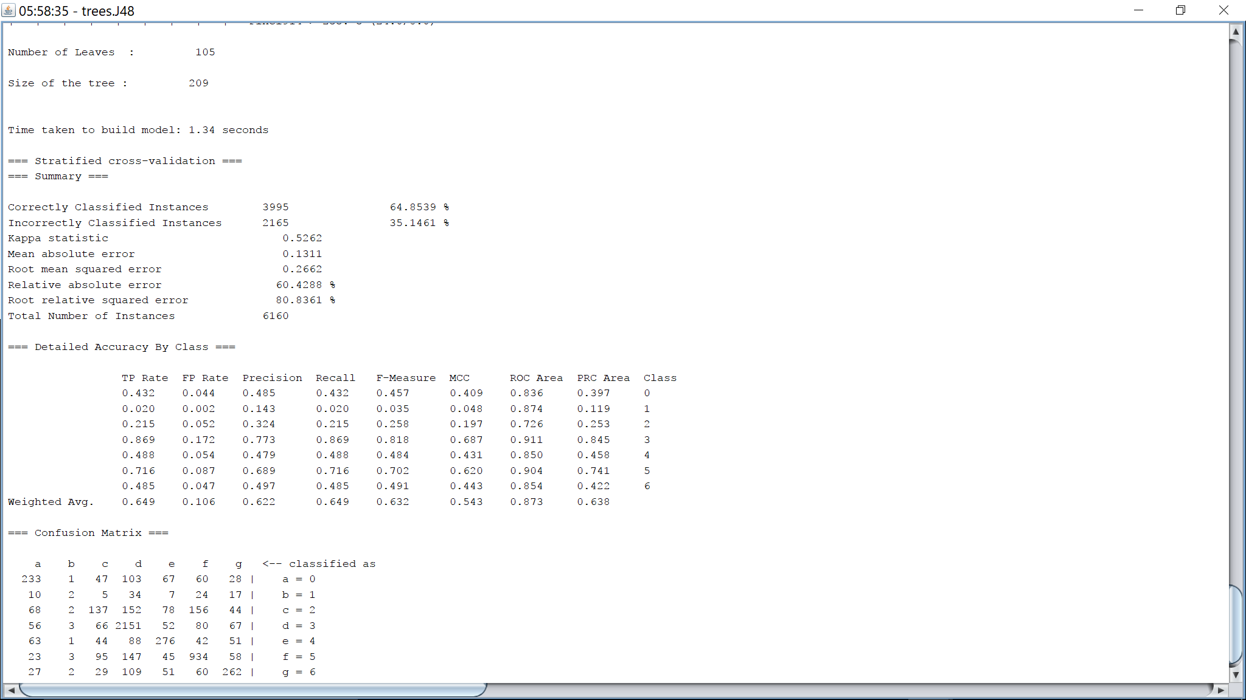

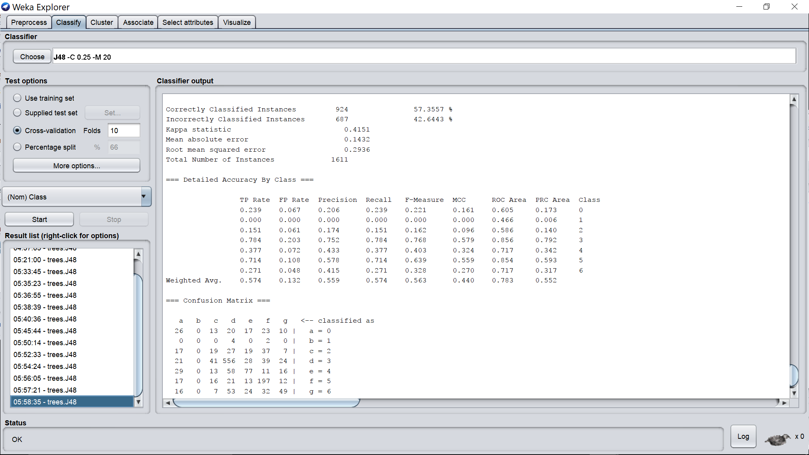

Binary spits 🡪 false

Unpruned 🡪 false

Confidence factor 🡪 0.25

Minimal number of objects 🡪 50

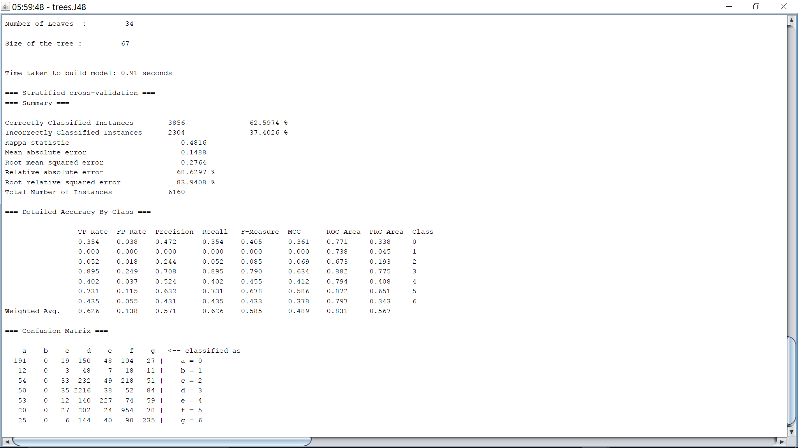

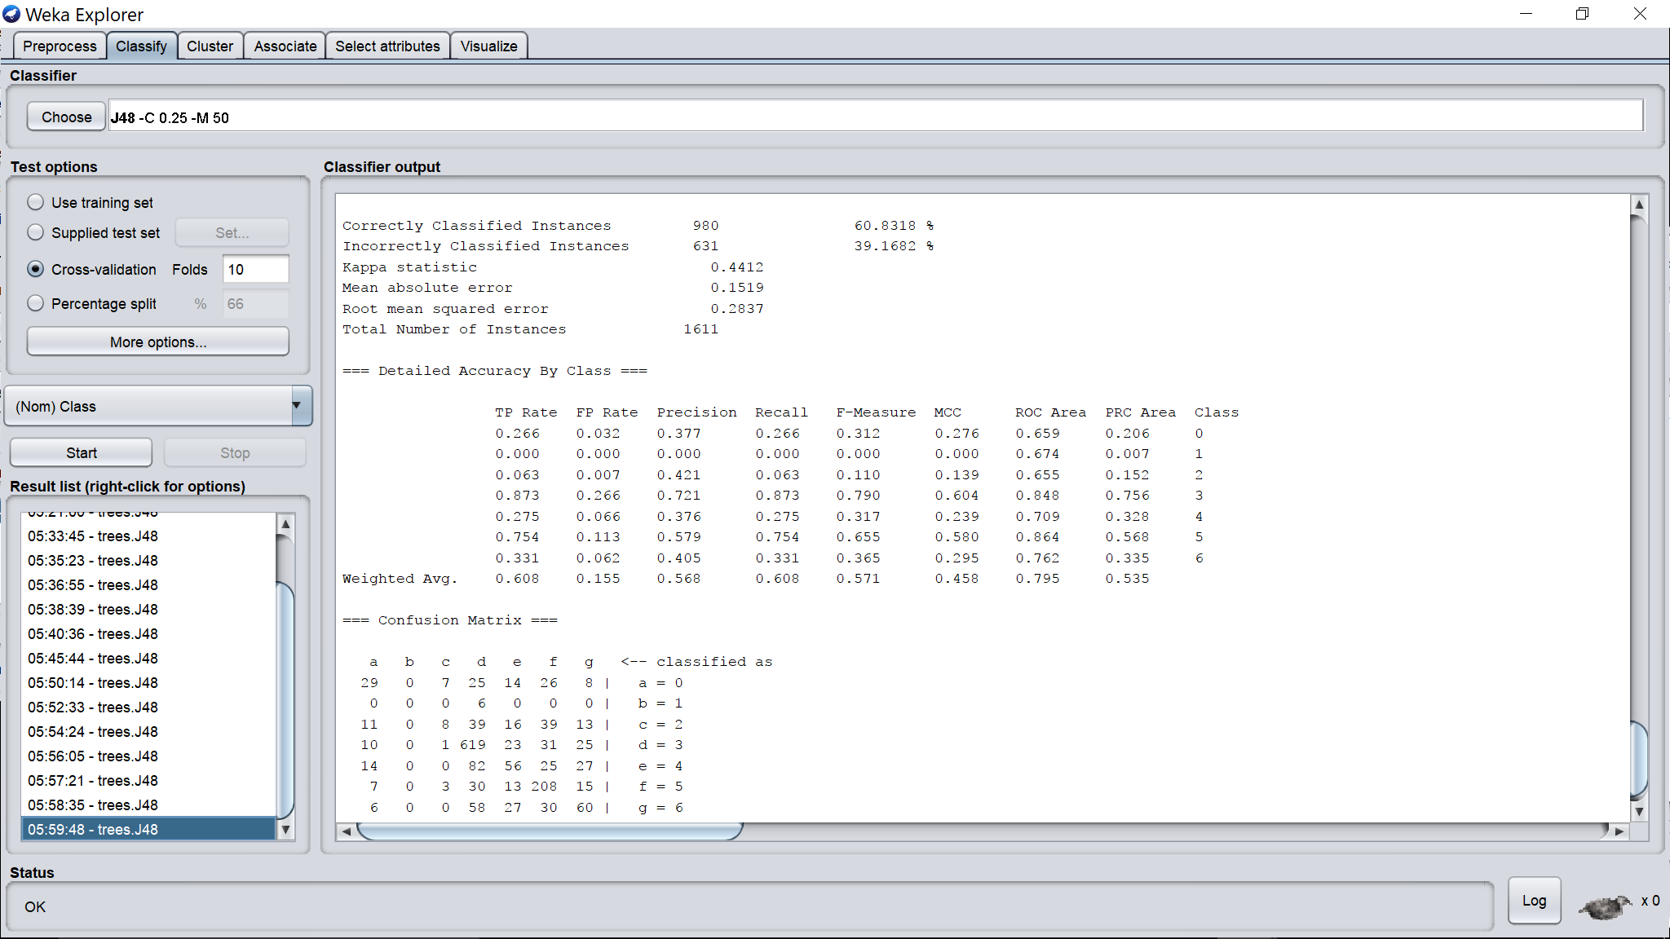

Binary spits 🡪 false

Unpruned 🡪 false

Confidence factor 🡪 0.25

Minimal number of objects 🡪 100

